COMPARATIVE STUDY
Low-Code Development vs. Traditional Application Development
An Analysis of Speed, Cost, Flexibility, and Long-Term Viability

ROSHAN K

241401083

CSBS

1. Introduction
Organizations today face growing pressure to deliver software faster, at lower cost, and with fewer specialized engineering resources than ever before. Two broad approaches dominate how modern applications get built: low-code development, which relies on visual, model-driven tools to assemble applications with minimal hand-written code, and traditional development, which relies on professional software engineers writing source code in languages such as Java, Python, or JavaScript. This report compares the two approaches across development speed, cost, flexibility, scalability, governance, and long-term maintainability, and offers guidance on when each approach is the better fit.
Low-code platforms (such as OutSystems, Mendix, Microsoft Power Apps, and Appian) have grown rapidly because they let business analysts and "citizen developers" build functional applications through drag-and-drop interfaces, pre-built templates, and configurable workflows. Traditional development remains the standard for building complex, highly customized, or performance-critical systems where full control over the code base is essential.

2. Overview of the Two Approaches

2.1 Low-Code Development
Low-code development uses visual modeling tools, drag-and-drop components, and pre-configured logic blocks to assemble applications. Developers — often including non-technical "citizen developers" — connect these building blocks visually rather than writing extensive code line by line. Most platforms still allow developers to drop into custom script for edge cases, but the majority of the application is produced through configuration rather than programming.

2.2 Traditional Application Development
Traditional development follows the classical software engineering lifecycle: requirements gathering, architecture and design, hand-written coding, testing, and deployment. Developers have full control over the technology stack, data structures, and application logic, which supports highly customized and performance-tuned systems, at the cost of longer timelines and higher specialist staffing needs.
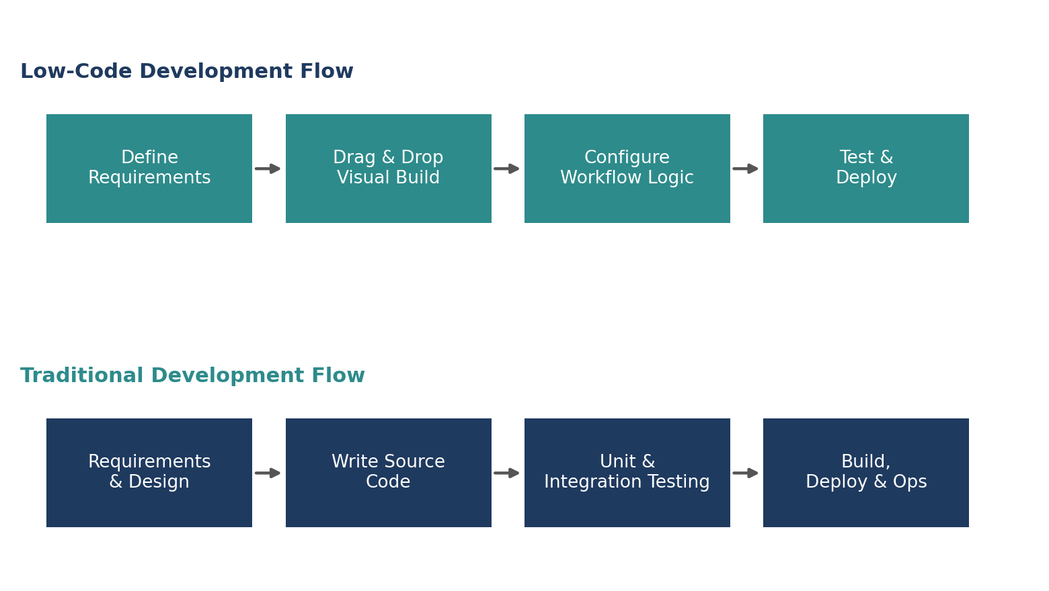
Figure 1: Simplified process flow — Low-Code vs. Traditional development lifecycles

3. Development Speed
One of the most cited advantages of low-code platforms is faster time-to-market. Because much of the interface, data model, and workflow logic is pre-built or visually configured, low-code projects typically move from concept to working application in a fraction of the time required by traditional coding. The chart below illustrates average development timelines across project sizes, based on industry benchmarks.
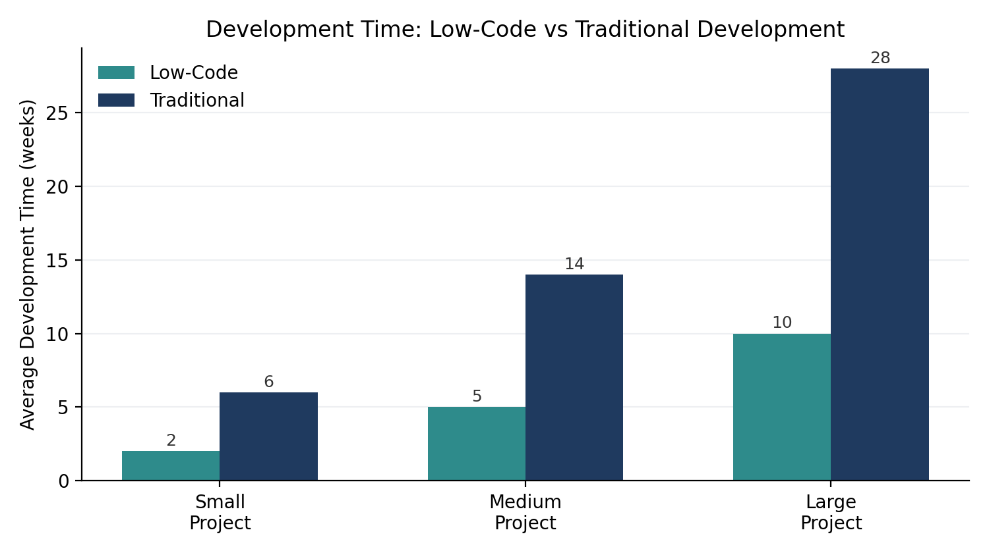
Figure 2: Average development time by project size, in weeks
For small, well-defined applications, low-code platforms can cut delivery time by roughly two-thirds. The gap narrows somewhat for larger, more complex projects, where custom integrations and edge-case logic require developers to extend the platform beyond its native capabilities.

4. Cost Comparison
Cost differences between the two approaches show up across several categories: initial build cost, ongoing maintenance, training and onboarding, and licensing. Low-code platforms generally reduce initial development cost and lower the skill bar for maintenance, but introduce ongoing subscription or per-app licensing fees that traditional, self-hosted code bases do not carry.
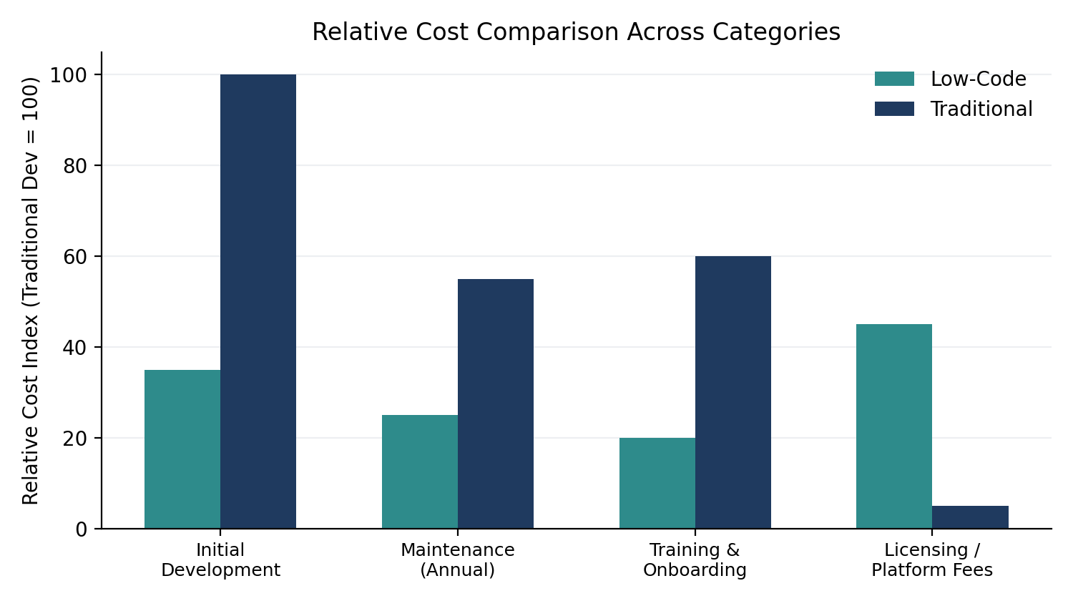
Figure 3: Relative cost index across categories (traditional development initial cost indexed at 100)
Over a multi-year horizon, the total cost of ownership depends heavily on scale: low-code tends to be more economical for small to mid-sized applications and internal tools, while traditional development can become more cost-effective at very large scale, where platform licensing fees compound and custom-built efficiency gains outweigh the faster initial build.

5. Capability Profile
Beyond speed and cost, the two approaches differ meaningfully in flexibility, scalability, governance, and maintainability. The radar chart below scores each approach on a 1–10 scale across six capability dimensions, based on common patterns reported across enterprise case studies.
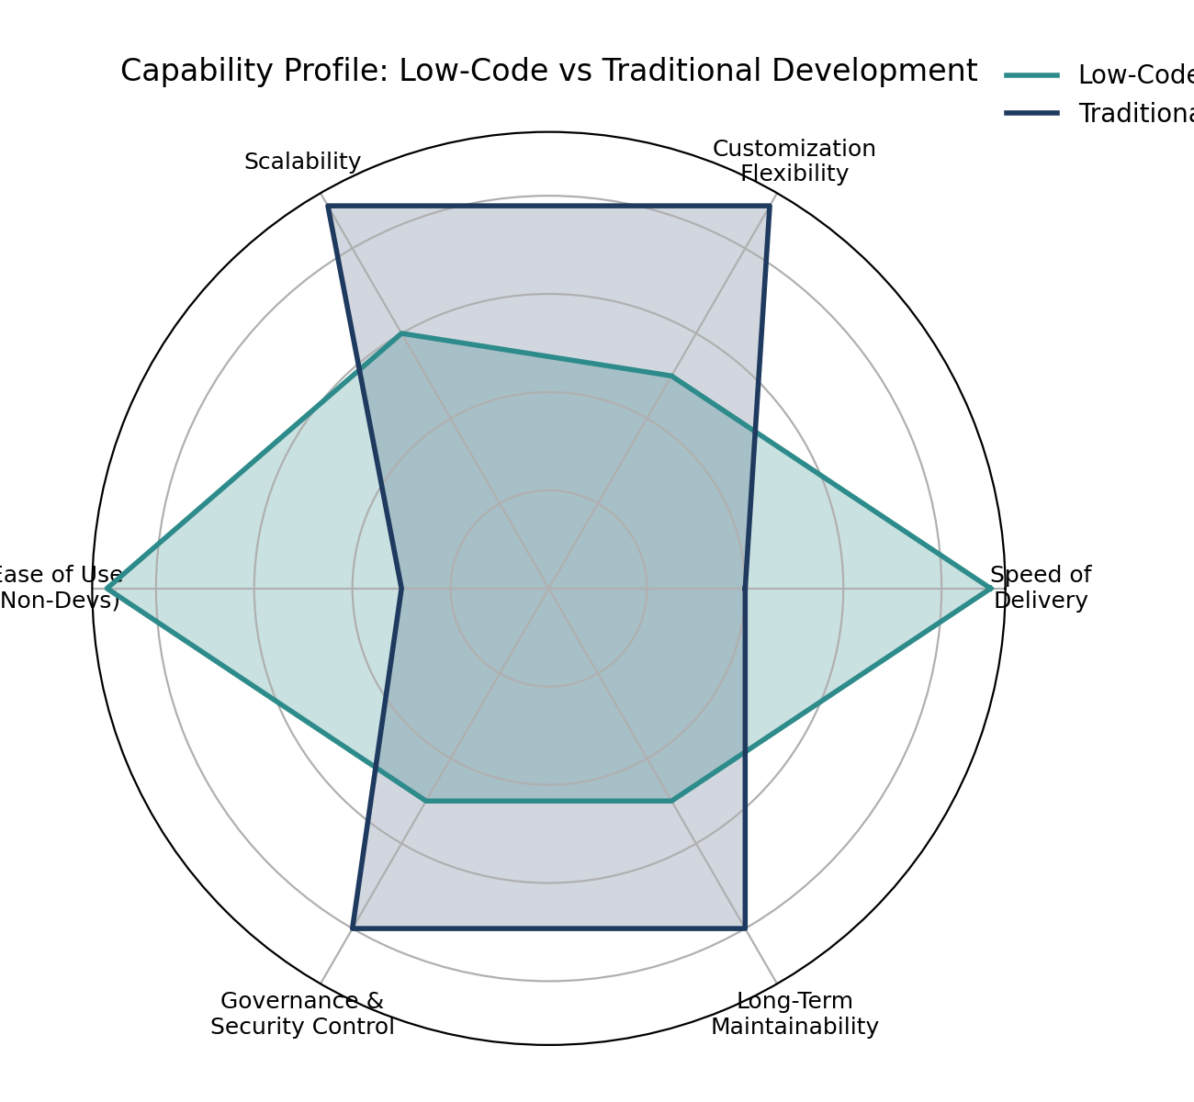
Figure 4: Capability profile comparison across six dimensions

6. Detailed Comparison
The table below summarizes the core trade-offs between low-code and traditional development across the criteria most relevant to technology decision-makers.

Criterion | Low-Code Development | Traditional Development
Development Speed | Fast — days to weeks | Slower — weeks to months
Required Skill Level | Low to moderate; business users can contribute | High; requires trained software engineers
Customization | Limited by platform capabilities | Virtually unlimited
Scalability | Good for small/mid workloads; can hit platform limits | Excellent; architecture built for scale
Initial Cost | Lower | Higher
Ongoing Cost | Subscription / per-app licensing fees | Primarily staffing and infrastructure
Maintenance | Simplified via visual tools | Requires ongoing engineering effort
Vendor Lock-in | Higher — tied to platform | Low — code is portable
Governance & Security | Managed by platform vendor | Fully controlled by the organization
Best Fit | Internal tools, MVPs, workflow apps | Complex, mission-critical, high-scale systems

7. When to Choose Each Approach

7.1 Choose Low-Code When:
- The application is an internal tool, workflow automation, or minimum viable product (MVP).
- Time-to-market is the top priority and requirements are relatively standard.
- The team has limited access to specialized software engineers.
- The expected user base and data volumes are small to moderate.

7.2 Choose Traditional Development When:
- The application requires deep customization, unique business logic, or novel user experiences.
- Performance, scalability, or regulatory requirements demand full control over the technology stack.
- The system is expected to operate at large scale over many years.
- Long-term cost control and freedom from vendor lock-in are priorities.

8. Conclusion
Neither approach is universally superior — the right choice depends on project scope, timeline, budget, in-house skills, and long-term strategic goals. Low-code development offers compelling advantages in speed, accessibility, and initial cost for straightforward applications and internal tools, while traditional development remains the stronger choice for complex, high-scale, or highly customized systems where long-term control and performance are paramount. Many organizations are increasingly adopting a hybrid strategy — using low-code platforms for rapid internal tooling and citizen-developer initiatives, while reserving traditional development for core, mission-critical systems that define competitive advantage.

